|  |  |  |
| --- | --- | --- |
|  | |  | | --- | | **ATTACHMENT A** | |

**Maintenance Matters**

Documents & Evidence Checklist

Name of Party: ___________________________________________

Case Number/s: ___________________________________________

*For each case number, indicate if you are the Applicant or Respondent.*

Next Court Event Date: __________ (Date) /___________ (Month) / 20____

Court Number: ___________

Notes:

1. This Documents and Evidence Checklist **only applies** to applications made under **Section 72** Women’s Charter for a variation/suspension/rescission **for yourself and/or your child(ren)**.
2. This Checklist corresponds with an E-Template Statement (“ETS”) in Form 28B (for Applicant) or Form 28E (for Respondent) which you have been previously directed to download and fill up.
3. Please read the explanatory notes after this checklist on *how to prepare your documents and this checklist*.



|  |  |  |  |
| --- | --- | --- | --- |
| **SECTION** | **DOCUMENT** | **PAGE**  **NUMBER**  **IN YOUR**  **BUNDLE** | **REMARKS** |
|  | This checklist | -- | 1. This checklist must be the **first document** in your bundle, and forms   the **Contents Page** of your bundle of documents.   1. You must arrange your documents in the order listed in the checklist 2. Please ensure that that your documents are paginated **as one continuous pagination from start to end**. 3. **Do not** paginate each type of document separately 4. All details must be filled up. |
| - | A copy of your E-Template Statement (“ETS”) in Form 28B (for Applicant) / Form 28E (for Respondent) |  |  |
| 1 | Documents relating to your personal particulars |  |  |
| 2 | Documents relating to particulars of marriage |  |  |
| 3 | Evidence of Respondent’s payment of maintenance (e.g., deposit slips or transfer receipts) |  |  |
| 4 | Employment evidence (e.g., employment contract) |  |  |
| Payslips for last 6 months |  |  |
| CPF Statements for last 6 months |  |  |
| IRAS Notice of Assessment for past 3 years |  |  |
| Documents showing proof of other sources of income |  |  |
| Documents proving social welfare or financial assistance |  |  |
| 5 | Documents showing value of **property(s)** |  |  |
| Documents showing value of **securities** |  |  |
| **Bank statements** for the past 6 months |  |  |
| Documents showing value of **vehicle(s)** |  |  |
| Documents showing value of other **asset(s)** |  |  |
| 6 | Documents and receipts to prove debts and liabilities |  |  |
| 7 | Documents and receipts showing proof of **personal expenses** |  |  |
| Documents and receipts showing proof of **child(ren)’s expenses** |  |  |
| 8 | Bankruptcy Order or any Court Order relating to such Bankruptcy (if any) |  |  |
| Other supporting documents in relation to other further information you wish to inform the Court. |  |  |

# WHAT TO NOTE WHEN PREPARING YOUR BUNDLE OF DOCUMENTS

1. The listing of required documents is in accordance with Paragraph 35(3), Form 28B (for Applicant) and Form 28E (for Respondent) of the Family Justice Courts Practice Directions 2024. A failure to produce the documents could be held against you at the trial unless you are able to show that they are not relevant in your case or the documents cannot be produced. The responsibility to prepare and produce documents falls entirely on you.
2. The Checklist in page i-ii is intended to assist litigants who are not represented. Counsels are freeto use this as well.
3. The Checklist in page i-ii must be included as the first document of your bundle and serves as the **Contents Page** of your bundle of documents:
   1. Every box in the “Page Number” column (right-most column) of the Checklist must *not* be left blank: If the item listed is provided, state the page numbers for that item depending on how many pages it has. If the item is not provided, cross out the box instead of filling in a page number.
   2. 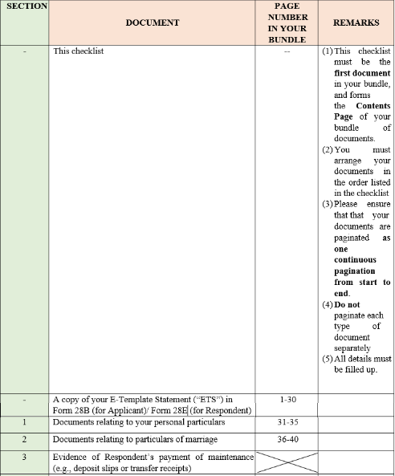An example:
4. If your E-Template Statement has 30 pages, it will be pages 1-30 in your bundle, and you are to fill in “***1-30***” as their page numbers.
5. After that, if your documents relating to your personal particulars takes 5 pages, you are to fill in “***31-35***” as their page numbers. Do the same for subsequent documents.
6. Assuming you do not have any documents showing the Respondent’s payment of maintenance, the corresponding box should be crossed out.
7. If you are preparing hard copies:
   1. Your documents must be either stapled or bound or placed in a file. Page numbers must beindicated at the bottom right corner of every page. Pages 1, 2, 3 and 4 are already indicated at the bottom of this Checklist.
   2. Three identical sets of everything are needed: one set is for submission to court, another is forexchange with the opposite party, and the third set is for your own reference at the trial.
8. If you are preparing soft copies, you may use the Microsoft Word version of this Checklist. Pagenumbers must still be inserted on individual soft copy documents for easy reference during thetrial.
9. Other instructions (e.g. on exchange and submission of the documents) are found in otherAttachments.
10. Any document not in the English language must be professionally translated before submission to court.
11. Please ensure that you review this checklist carefully when submitting your documents. Please note that after you have submitted your documents, no further witnesses, affidavits or evidence will be allowed except with the permission of the **Hearing Judge**