 | ATTACHMENT A

Maintenance Matters
Documents & Evidence Checklist
Name of Party:
Case Number/s:
Include all related maintenance matters that are dealt with together. Use a separate checklist if your related
matter is a PPO matter.
For each case number, indicate if you are the Applicant or Respondent.
Next Court Event Date: Court Number: | (Date) / (Month) / 20____

There are 3 types of maintenance-related matters:
- Section 69 Women’s Charter (“WC”) “Fresh maintenance” matters, for spouse and/or children. This is where there is no existing maintenance order and the Complainant now seeks an order.
- Section 72 WC “Variation/rescission” matters, where there is an existing maintenance order and either party seeks to vary, suspend or rescind it.
- Section 71 or Section 80 WC “Enforcement” matters, where there is an existing maintenance order which a Complainant alleges the Respondent has not complied with and wishes to enforce.

The documents that are needed depends on which of these your matter is.
DOCUMENT | “FRESH  MAINTENANCE” MATTERS | “VARIATION/  RESCISSION”  MATTERS | “ENFORCEMENT” MATTERS | PAGE NUMBER IN YOUR BUNDLE
This checklist | This checklist must be the first document in your bundle, and  forms the Contents Page of your bundle of documents. All  details must be filled up. |  |  | --
Fresh Maintenance Matters  Form 28A for Applicant Form 28D for Respondent  Variation/Recission Matters  Form 28B for Applicant Form 28E for Respondent  Enforcement matters  Form 28C for Applicant Form 28F for Respondent | ✓ | ✓ | ✓
List of your monthly  expenses, including  expense for children, if applicable (“List of Expenses” form to be used) |  |  | ✓  For Respondent only
Documents and receipts to prove expenses listed in the List of Expenses Form 28A-E | ✓ | ✓ | ✓  For Respondent only
Documents and receipts to prove debts listed in the List of Expenses or Form 28A-E | ✓ | ✓ | ✓  For Respondent only
Payslips for last 6 months | ✓ | ✓ | ✓  For Respondent only
CPF Statements for last 6 months | ✓ | ✓ | ✓  For Respondent only
Employment evidence  (e.g., employment  contract) | ✓ | ✓ | ✓  For Respondent only
IRAS Notice of Assessment for past 3 years | ✓ | ✓ | ✓  For Respondent only
Updated bank passbooks or statements for the past 6 months | ✓ | ✓ | ✓  For Respondent only
Evidence of payment of maintenance (e.g., deposit slips or transfer receipts) | ✓ | ✓ | ✓  For Respondent only
Computation of arrears of maintenance  (“Calculation of  Arrears” form to be used) |  |  | ✓
Previous Maintenance  Order (MO) or Variation  Order (VO) or Enforcement of Maintenance Order (EMO) |  | ✓  For  Applicant  only | ✓  For Complainant only
Bankruptcy Order or any Court Order relating such Bankruptcy (if any) | ✓ | ✓ | ✓

WHAT TO NOTE WHEN PREPARING YOUR BUNDLE OF DOCUMENTS
1. The listing of required documents is in accordance with the applicable forms set out in Paragraph 35(3) of the Family Justice Courts Practice Directions 2024. A failure to produce the documents could be held against you at the trial unless you are able to show that they are not relevant in your case or the documents cannot be produced. The responsibility to prepare and produce documents falls entirely on you.
2. The Checklist in page i-ii is intended to assist litigants who are not represented. Counsel are free to use this as well.
3. The Checklist in page i-ii must be included as the first document of your bundle and serve as the Contents Page of your bundle of documents (the English version of Attachment A is to be used):
- Every box in the “Page Number” column (right-most column) of the Checklist must not be left blank: If the item listed is provided, state the page numbers for that item depending on how many pages it has. If the item is not provided, cross out the box instead of filling in a page number.
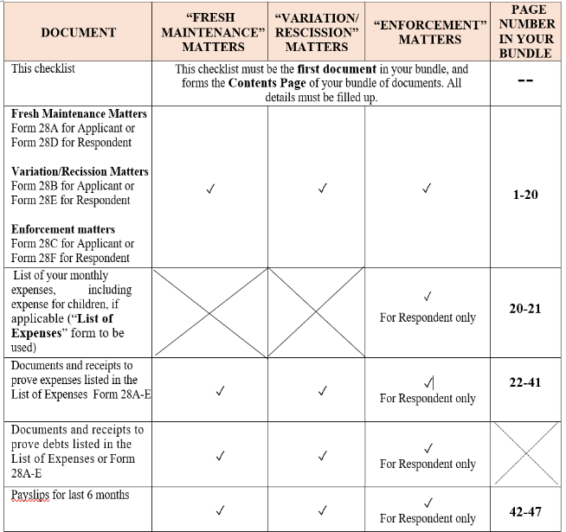
- An example:
- If your “Form 28F” form has 20 pages, it will be pages 1-20 in your bundle, and you are to fill in “1-20” as their page numbers.
- After that, if your “List of Expenses” form has 2 pages, you are to fill in “20-21
- After that, if your documents and receipts to prove the expenses listed in your “List of Expenses” form takes 20 pages, you are to fill in “22-41” as their page numbers. Do the same for subsequent documents.
- Assuming you do not have any debts and hence no documents or receipts to prove the debts, the corresponding box should be crossed out.
4. If you are preparing hard copies:
- Your documents must be either stapled or bound or placed in a file. Page numbers must be indicated at the bottom right corner of every page. Pages 1, 2, 3 and 4 are already indicated on the Checklist.
- Three identical sets of everything are needed: one set is for submission to court, another is for exchange with the opposite party, and the third set is for your own reference at the trial.
5. If you are preparing soft copies, you may use the Microsoft Word version of this Checklist. Page numbers must still be inserted on individual soft copy documents for easy reference during the trial.
6. Other instructions (e.g. on exchange and submission of the documents) are found in other Attachments.
7. Any document not in the English language must be professionally translated before submission to court.
8. Please ensure that you review this checklist carefully when submitting your documents. Please note that after you have submitted your documents, no further witnesses, affidavits or evidence will be allowed except with the permission of the Hearing Judge.

