Law Firm Admin - Changing law firm of counsel

When counsel acts for an accused in a case which has been registered via the Integrated Criminal Case Filing and Management System (‘ICMS’), counsel has access to the eCase file only after the court officer has linked counsel to the case upon submission of the attendance slip at the first appearance.

When there has been a change of law firm, the particulars of counsel in the database may not have been updated due to the time lag in receiving the data. In such an instance, the court officer is unable to update the law firm on behalf of counsel and link him to the case.

Instead, it is the duty of counsel to ensure that his former law firm deactivates his account and the new law firm which he has joined creates an account for him.

To assist law firms to effect such a change, a brief guide has been prepared. In the example, Lawyer B who was with Law Firm B has left the firm and joined Law Firm A.

Steps to deactivate account of Lawyer B by Law Firm B

Step 1: Select Law Firm Admin
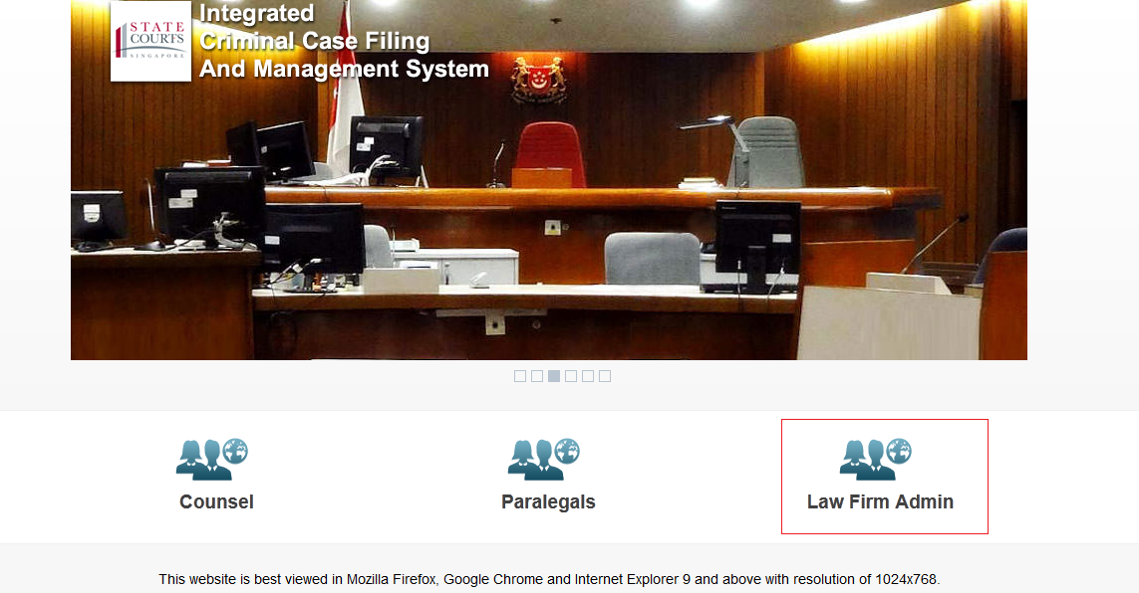

Step 2: Login in using SingPass ID


Step 3: At the top right of the menu bar, click on ‘Admin’ and select ‘Manage Counsel’ from the drop down menu.

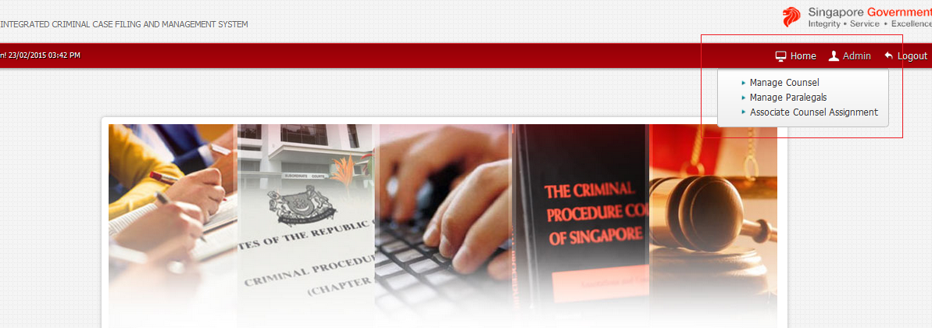

Step 4: To remove Lawyer B, click the ‘x’ icon in the row bearing his name under the Action column. Lawyer B’s account with Law Firm B would thereafter have been deactivated.
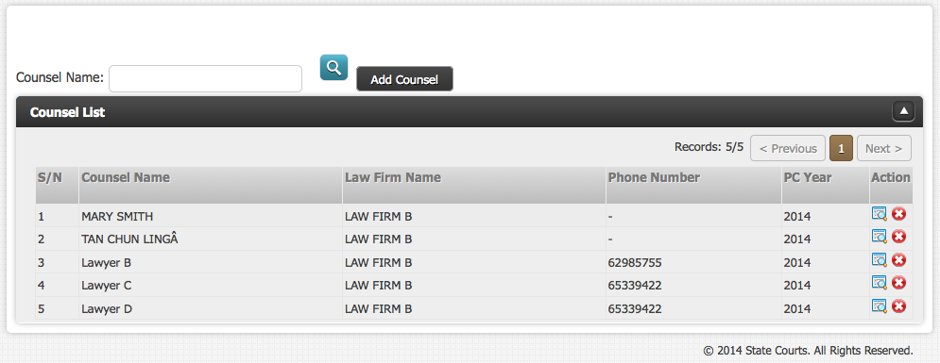

Steps by Law Firm A to create an account for Lawyer B

See Steps 1 and 2 above, i.e. click ‘Law Firm Admin’ and login using SingPass. Thereafter, click on ‘Admin’ at the menu bar and select ‘Manage Counsel’.

Step 3: Click the ‘Add Counsel’ button.

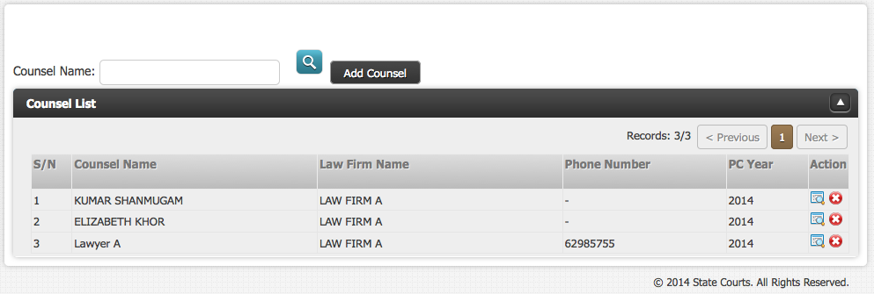

Step 4: Select Lawyer B who is to be added by checking the checkbox in the ‘Select’ column and thereafter click the ‘Add Counsel to Law Firm’ button.

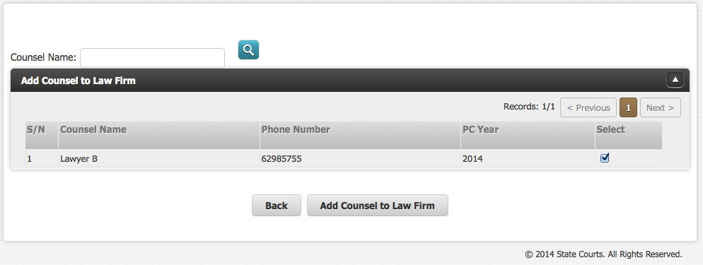

Lawyer B will then be added to the list of counsel of Law Firm A and his account will thereby have been created.
